



***Digital Canvas Project Proposal***

***22 August 2014***

Team Details

|  |  |  |  |
| --- | --- | --- | --- |
| Name | Major | Role | Contact Info |
| Evan Martin | Software Development | Project Leader | [evanmnz@gmail.com](mailto:evanmnz@gmail.com)  0272529779 |
| Ben Liang | Software Development | Software Developer | [benliangforloop@gmail.com](mailto:benliangforloop@gmail.com)  02102846138 |
| Alastair Bowie | Software Development | Quality Assurance | [alastairbowie94@gmail.com](mailto:alastairbowie94@gmail.com)  0211841043 |
| Pio Kim | Software Development | Researcher | [beo1597@gmail.com](mailto:beo1597@gmail.com)  021250839 |

Stakeholders

|  |  |  |  |
| --- | --- | --- | --- |
| Andrew Colarik |  | Project Supervisor | acolarik@hotmail.com |
| Matthew Martin |  | Client | [martyfly.ta@gmail.com](mailto:martyfly.ta@gmail.com) |
| Nolwenn Lacire |  | Stakeholder - Digital Art Live Program curator at Aotea Center | [nolwennL@aucklandlive.co.nz](mailto:nolwennL@aucklandlive.co.nz) |

Table of Contents

Client Introduction 5

Project Overview 5

Aim 6

Scope 6

1. Stability 6

2. Software Improvements 6

3. User interface Improvements 6

Outside of project scope 6

Current Limitations 7

Project Approach 8

System Analysis 8

Requirements Engineering 8

Design System 8

Development 9

Testing 9

Unit testing 9

Black box testing 9

Acceptance testing 9

Quality Assurance 9

Activities 10

Sprints 10

Communication 10

Planning tools 10

Timeline 11

Development platform 13

Deliverables 14

Software Product 14

Skills and Knowledge 15

Costs 16

Hardware / Software 16

Risks and Solution 17

Project Plan 17

Other academic commitments 17

Sickness 17

AUT Research & Development Project Disclaimer 19

Appendix 20

A. Issues/Tasks 20

B. Client Meeting Q/A 21

C. Gantt chart 24

# Client Introduction

Matthew Martin is a Digital Media Artist with a Bachelor’s Degree in Creative Technologies he is currently taking his masters in Creative Technology at AUT. Matthew has been involved in numerous projects that have been displayed at exhibitions and conferences. Matthews project, Shadow Showdown has been published in Creativity and Cognitions in 2013.

# Project Overview

The Digital canvas project is to be used as an interactive art installation at the Auckland Live exposition at Aotea Centre. The public of all ages should be able to intuitively interact with the digital canvas using gestures to explore and mask areas of a live video feed of a performance happening on the theatre stage. Each interaction will record a video, which is then moved and looped on the digital canvas, thus creating a collage of overlapping videos.

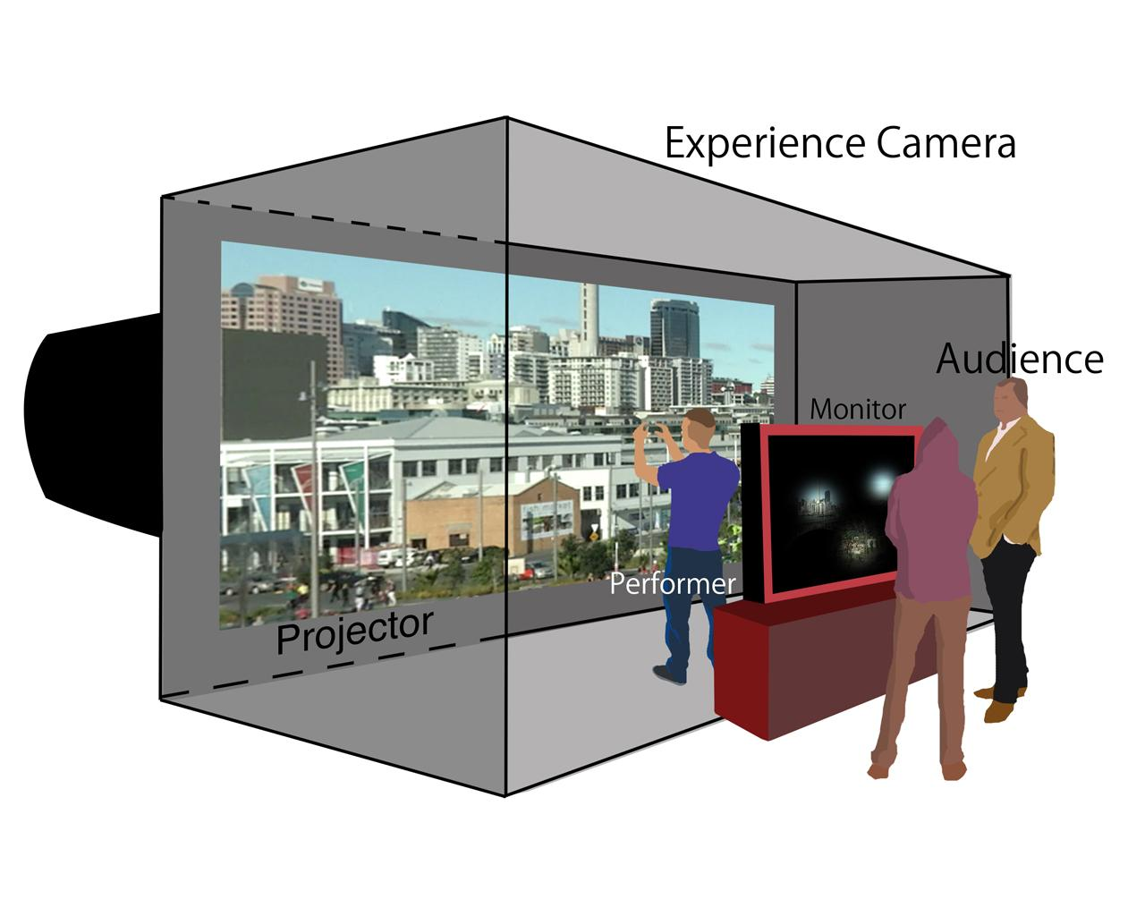

Currently there is a working prototype of the virtual canvas which has three major limitations. First, only two gestures are implemented. These gestures are the ability to mask the canvas using both hands to adjust the size, and the ability to move the mask around the canvas using one hand. Second the interface isn’t intuitive, the user has little feedback to acknowledge their interaction and has no cues to what gestures are available to use. Finally there are a number of technical issues to fix regarding stability, and gesture detection accuracy.

The current technical implementation uses a Microsoft Kinect to capture a 3D image of the user, a standard web camera which is then used to record a live performance, and a Mac computer running openFrameworks to handle gestures and video recording.

# 

# Aim

The goal of this project is to produce a digital canvas software package that will be used Auckland Live exposition. Our main focus is to ensure that the software can be maintained and run 24/7. The software will need to run automatically and execute by itself whenever the computer system turns on, so that assistance from technical experts will not be required. Finally the user interaction needs to be improved so that the Digital Canvas is easy for the wide range of visitors at Aotea Centre to use without specific instructions.

# Scope

## Stability

The live installation will run continuously for three months without any technical expert’s onsite to fix issues. For this reason making the system stable is very high priority.

* Address limitations to storage space, and parallel video playback by imposing hard limits within the software
* Provisions to safely reboot system and automatically start software in case of power failure or unexpected crash
* Implement a bug tracking system to record and track bug fixes

## Software Improvements

* Decrease the amount of physical input from technicians by setting up the program to run independently
* Improve performance by optimizing software resource consumption

## 3. User interface Improvements

The client has identified improved user interaction as an area where improvements can be made to the current system. The goal here is to allow intuitive interaction where the digital canvas can be used by a public of all ages without any prior training. Ideally Interacting with gestures should feel natural and not require any on screen help.

* Improve user feedback to acknowledge their interaction
* Add cues/hints for available gestures
* Usability testing

# Outside of project scope

* Live hardware installation and operations
* 3D gesture recognition
* Additional features

# Current Limitations

The prototype version still has some errors:

1. If there are objects near the performer the camera detects the objects rather than the performers’ hands, thus interrupting the signals provided by the gestures.
2. There is some delay of the rectangular view box when interacting with hands.
3. With one hand gestures, the software performs with low accuracy.

(See Appendix A. Issues/Tasks)

# Project Approach

## System Analysis

Our first task will be analysing the current software. This will involve reading all the code and documentation of the current system, as well as testing the software for bugs, and the integration between the hardware and software. At the end of this phase we will have a complete list of bugs, a high level understanding of the current system, and know whether or not to continue improving the current system or if we need to start with a new architecture.

* Bug List
* Software architecture design / plan

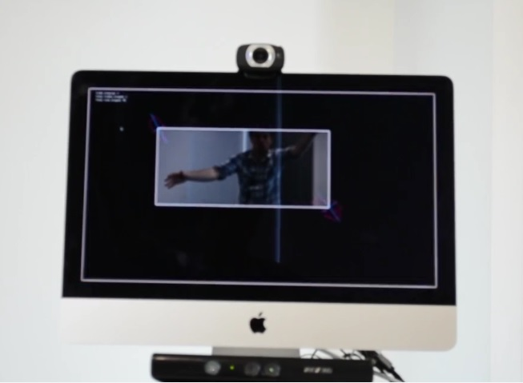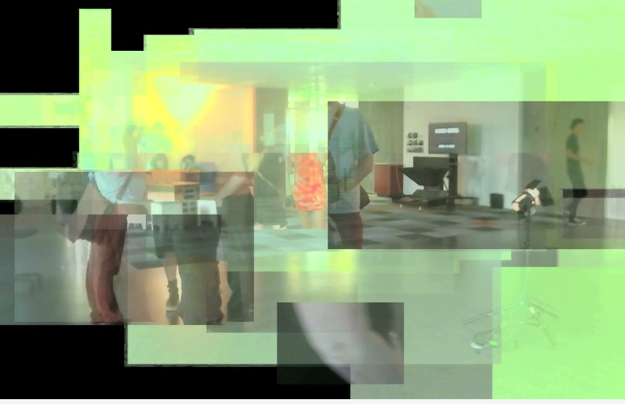

Figure 1: Screen shots of the current system from a video provided by out client,   
Matthew Martin (http://vimeo.com/80755572)

## Requirements Engineering

A full list of requirements will be written in the form of user stories then added to the project backlog along with acceptance tests in order to validate if the requirement has been met. A game of planning poker will be used to estimate the effort and priority of each user story.

* Write user stories
* Write acceptance tests
* Play planning poker
* Create project backlog

## Design System

Designing the system will involve developing UML diagrams describing the structure of the classes and mock-ups of the user interface.

* UML Class Diagrams
* User interface mock-ups

## Development

Incrementally develop code in sprints. After each sprint release a stable version of the software.

* Stable software release
* Updated bug list
* Updated burn down chart
* Updated project and sprint backlog

## Testing

In-order to ensure the software is stable, meets the requirements, and is fit for purpose we will utilize multiple testing methods.

Unit testingBefore writing each method multiple unit tests will be written to validate the output of the given function for each scenario. Then before each release the unit tests will be run to validate the software.

Black box testingBlack box testing will be used to validate the system as a whole. The software will be run on the development machine and each user story will be tried to ensure bug free operation.

Acceptance testingThe purpose of acceptance testing is to check if the software meets the clients specification. For each user story written in the requirement engineering phase the corresponding acceptance tests will be checked against the current state of the software.

## Quality Assurance

To ensure the quality of the software we produce we will utilize the software architecture pattern MVC, as well as use version control tools to track and control changes to the code, and finally review the code before making a stable release at the end of each sprint.

# Activities

Scrum has been selected as our software development methodology primarily because it can handle changing requirements. Scrum will provide the team with the flexibility to overcome unexpected changes and will offer the client value with fast iterations of software releases.

### Sprints

Development will occur in two week sprints. At the end of each sprint the development GIT branches will be merged into the master branch, which will then contain the latest stable version of the software to be shown to the client during the sprint retrospective.

### Communication

#### Sprint planning

Before each sprint a team meeting will be held to select the user stories to be completed, then update the project backlog; and negotiate how we will divide the workload.

#### Daily Stand up meeting

At the start of each day the development team will have a short meeting in WT505. The purpose of this meeting is to ask three questions - what have you done since yesterday? What are you planning to do today? Do you have any issues that are barriers to progress?

#### Sprint Retrospective

At the end of each two week sprint a retrospective will be held in order to reflect on the work completed and evaluate the overall progress. The latest stable version of the software will be demonstrated to our client.

### Planning tools

#### Project backlog

The project backlog will include a complete list of user stories, bug fixes, and non-functional requirements. Each backlog item will include estimations of work required to complete shown as story points, priority, and the number of hours already spent on the task. This document will be continually updated in order to keep track of the overall progress of the project.

#### Sprint backlog

The sprint backlog is similar to the project backlog, however it will only contain the user stories that have been selected for development in the current sprint. It will go into more detail as to what state each user story is in; such as writing unit tests, in development, testing, or completed.

#### Burn down chart

A burn down chart will be used to give the public an indication as to the current project progress verses the ideal progress. This chart will be updated daily after each user story has been completed in entirety. The chart will should velocity that will indicate how much work is being completed per sprint.

**Planning poker**

Planning poker brings together multiple opinions for estimation of each user story, we include everyone from development team. For each user story, attendees will have an estimate value in their mind from 0, 1, 2, 3, 5, 8, 13, 20, and 40 to 100. The highest and lowest estimators will explain their opinions, after discussion we will re-estimate until unanimous agreement.

# Timeline

|  |  |  |
| --- | --- | --- |
| Week | Tasks | Deliverables |
| 1 | Project allocation  Team members Introduction |  |
| 2 | Supervisor meeting  Preparation for Client meeting   * Make agenda questions * Research on relevant topics | Gain a general understanding of the project.(Appendix B. Client Meeting Q/A)  Client meeting notes |
| 3 | Gain a more thorough understanding of what the project is about and what we need to achieve in order to modify and improve the current system | Project proposal |
| 4 | Project Proposal Presentation  Feedback Allocation | Present the plan we are going to deliver for the project |
| 5 | Reorganise proposal  Client Meeting 2   * Proposal suggestion * Share ideas on cross-platform system   Setup development platform | * Revised Project Proposal * Visual Studio Project Setup |
| 6 | **Sprint 0**  System analysis   * Analyse code * Software / hardware integration testing   Research   * Test user interaction * Interaction research   Requirement engineering  Sprint planning | * Bug log document * Software architecture design / plan (UML) * User stories and acceptance tests * Project backlog |
| 7 | **Sprint 1**  - Testing and development | * Updated sprint and project backlog |
| 8 | - Testing And development  - Client meeting with demonstration | * Stable release #1 |
| 9 | **Sprint 2**  - Testing and development | * Sprint retrospective * Updated Sprint and project backlog |
| 10 | - Client meeting with demonstration | * Stable Release #2 |
| 11 | **Sprint 3**  - Testing and development | * Sprint retrospective * Updated sprint and project backlog |
| 12 | - Client meeting with demonstration | * Stable release #3 |

## Development platform

Our development platform will be a dedicated Windows computer in WT505. Microsoft Visual Studio 2013 will be used as an IDE, and GIT for version control. The client has provided the additional hardware we need including a Microsoft Kinect camera for motion capture and a regular webcam for the source video.

For our final testing phase we will use the space in WG1003 coLab which contains a Mac computer with dedicated graphics and dual screens. This will be used to ensure each release will perform correctly under the same conditions as the live installation.

# Deliverables

## Software Product

Our primary deliverable is to deliver a stable version of the source code and finalized compiled software. We already have the source code from the client, and we will incrementally release stable versions to the client. With each stable release we will compress the source code and compiled version as a zip file and email it to the client. This will show the client our progress continually and make sure we are on the right track.

# Skills and Knowledge

#### Time Management

As all team members have different timetables, this project requires excellent time management skills. To achieve this we must all take part in negotiating times which is suitable for everyone, including our supervisor, thus arrange adequate amounts of meetings for project discussion. All member have other assignments to complete, therefore we must utilise and make most of the available times we have. This means all members should participate in all meetings which have been negotiated prior.

#### Communication

In order to achieve good time management, having good communication skills is crucial. Effective communication will ensure that all members are on the right track and to keep and eye on areas where members may have difficulty. We will use a variety of communication tools including: Google drive, social networks, text messages and voice calling. As a result we will be able to keep track of our communication skills and improve on them if necessary. Having a variety also allows us to choose the method of communication most adequate to our needs at the time, for example, using Google drive when we want all members to proofread or directly calling team members if they cannot be contacted through other tools.

#### Technical skills

As we mainly focus on Java object-oriented programming language in our degree, C++ is not familiar to us. To be honest, we are still not confident with C++ coding, and developing complex computer graphics. The fact is that Apple doesn’t provide an official version for windows users. Alternatively, openFrameworks is available on code:blocks and visual studio, window users can develop without too much issue. Besides, in order to keep the budget to minimum, we only can test the software at colLab WG1003, because it has the powerful graphics card. Apart from the limitation, C++ is easy to learn, as there are many learning resource online.

#### Research

In order to gain the knowledge of improving the installation, researching in single perspective is insufficient, we might come up with something new along the way. So far, we have researched on heads-up user-interface, projection, openFrameworks, motion capture, Kinect + motion capture, gesture recognition and openGL 3D graphics (Appendix). In order to keep creative on this, we are likely to stay focus on one particular perspective, in order to get more ideas from each members.

# Costs

## Hardware / Software

|  |  |  |
| --- | --- | --- |
| Product | Retail Cost | Actual Cost |
| Microsoft Kinect | ~$99 | $0 |
| Web Camera | < $100 | $0 |
| iMac | > $1,549.00 | $0 |
| Max OS X | ~$25 | $0 |
| openFrameworks | $0 | $0 |
| Xcode | $0 | $0 |

The Kinect, software, and web camera have been provided at no cost from the client.(Appendix D) For testing and development a high performance computer is required (discrete graphics is essential to process parallel video streams). Hopefully this will be available in the project lab provided by AUT.

# Risks and Solution

## Project Plan

Due to unforeseen circumstances the project plan may not always follow accordingly. The project plan should just be an overview of the overall progress however it should not be a rigid plan which cannot be changed. In order to have a successful project the team must be prepared to meet challenges which may alter the initial project plan. Some changes may involve sickness or bereavement as discuss prior; a client may want to change aspects of their requirements, and any other unexpected circumstances. If the team is unaware of unexpected circumstances which are capable of altering the project plan, the project load may become uncontrollable and the team may lose confidence, thus impacting the clients and supervisor satisfaction.

**Solution:**

To prevent significant impact on the project plan and thus maintain good team performance, task progress should be strictly monitored and members should check on each other so that no one is falling behind. Another prevention strategy would be to keep the client updated about the team’s progress and make sure the team is meeting the client’s requirements. If this is carried out effectively the client will also have an early opportunity to change any requirements if necessary.

## Other academic commitments

Three out of the four team members are enrolled in more than three papers and have to balance their work load and due dates to make sure they meet the requirements for all of their papers including this project. If the team cannot support each other or are unable to share an equal workload it may affect their performance on the project, for example: poor time management will result in incomplete tasks; a large workload may prevent a member from having time to attend meetings. If these problems arise, the final project outcome may be incomplete or unfinished which means the team cannot meet the client and supervisors expectations.

**Solution:**

In order to prevent the impacts mentioned above and any further complications communication and support amongst team members is vital to keep this project running smoothly. The team should look out for one another and ensure that everyone is confident about their personal time management and are not overwhelmed by their allocated tasks as well as other papers’ commitments.

## Sickness

Sickness of self or bereavement of a family member can impact the progress of the project as the team member in context will need to be excused for some time, depending on their situation. This means that the remaining members must make up for the loss of a member and increase their workload to prevent the project from falling behind schedule.

**Solution:**

In order to keep all members informed and up to date with each other’s’ work, all documents are to be uploaded onto Google Drive so that progress can be monitored by everyone. Tasks can be re-allocated and deadlines should be flexible in preparation for unforeseen circumstances such as sickness or bereavement.

# AUT Research & Development Project Disclaimer

Clients should note the general basis upon which the Auckland University of Technology undertakes its student projects on behalf of external sponsors:

While all due care and diligence will be expected to be taken by the students, (acting in software development, research or other IT professional capacities), and the Auckland University of Technology, and student efforts will be supervised by experienced AUT lecturers, it must be recognised that these projects are undertaken in the course of student instruction. There is therefore no guarantee that students will succeed in their efforts.

This inherently means that the client assumes a degree of risk. This is part of an arrangement, which is intended to be of mutual benefit. On completion of the project it is hoped that the client will receive a professionally documented and soundly constructed working software application, some part thereof, or other appropriate set of IT artefacts, while the students are exposed to live external environments and problems, in a realistic project and customer context.

In consequence of the above, the students, acting in their assigned professional capacities and the Auckland University of Technology, disclaim responsibility and offer no warranty in respect of the “technology solution” or services delivered, (e.g. a “software application” and its associated documentation),both in relation to their use and results from their use.

# Appendix

### A. Issues/Tasks

Below is a table of the future current issues with the installation including future goals and outcomes.

|  |  |  |
| --- | --- | --- |
| **Bug** | **Description** | **Tasks** |
| Freezing (Major) | * Program freezes occasionally while stopping/uploading video. * It only freezes after a person has interacted with the installation and is changing between video playbacks. * It could be caused by a data leak from the video recorded (although error happens with loading a new video). | * 3 video playbacks alternating, allowing time between a video ‘renderings’ out and when it is required to play.   Finding an alternative video playback system.   * Having 2 video players in the program instead of 2 videos swapping between |
| Delay (Major) | * Video mask delayed compared to rectangle outline. | * Would need to find a way for both live video and live rectangle being on the same screen without rectangle being recorded. |
| Multiple cameras (Major) | * Record a show and create a video loop for the audience to interact with. * Have a camera live for users to interact with. | * This will be decided depending on permission for recording theatre performers. |
| One hand detection (Minor) | * Software sometimes does not register a blob when only one hand is visible. * Video mask disappears. | * Will need to seek exact spot of where detection of blob is slipping. Most likely an ‘if’ statement error. As a last resort the option of removing one hand detection is possible. |
| Usability (Minor) | * Difficult for users to understand how close their hands need to be without interference from their stomach. | * User feedback. * Visual cues explaining how to use it * Emphasis on the detection of player’s body parts. * Re-do designated hand positions code. * Recalibrate blob detection. |

### B. Client Meeting Q/A

#### Purpose

* In the project prospectus it mentioned there will be a live demonstration or a viewing of video created with the virtual canvas at the Auckland Live event. Is this the primary purpose of the project?
  + The primary purpose of this project is to have it installed early next year in Auckland Live, running for a few months without issue. Currently there is no planned event but will most likely be dated to be displayed alongside one of the theatre performances in March-April. This is for quality content purposes for Digital Canvas. The only live demonstration outside of public use would be on the projects premiere night.
* What will happen with the system after the Auckland Live event? Will it become a software package that can be installed and used on any machine with the right configuration? Or are we working with a single installation that will be used for multiple events?
  + The software is to be designed so it can be installed for multiple events (different screens sizes etc.). There needs to be an easy transition between settings up between different events. The hardware (Kinect, iMac, webcam) is fairly standard and should not be expected to change.
* The project prospectus mentions the system needs to be stable for continuous operation. Does this mean the public will be playing with the digital canvas during the Auckland live event? If so will the system need to be locked down so guests cannot break the software?
  + The public will be interacting with the installation over the few months it is on display. It needs to be assured the software will not break.
* Who owns the project / intellectual property?
  + The project is owned by the author Matthew Martin. If the developers use the code given then Matthew Martin is to be stated as one of the co-developers.
* Is this a non-profit project for Auckland Live? Or is payment involved? []
  + Non-profit
* What is your target demographic? All ages?
  + All ages have access to the installation during the day and should be expected to be interacting. However keep in mind theatre customers will be the larger part of the demographic.

#### Vision

* What gestures would you like added to the system?
  + Currently the software allows the user to interact using two hands for position and size coordinates while using one hand keeps to the position only. As long as it is stable and accurate to use there does not need to be more gestures added. If a gesture that is more intuitive and easier to learn is suggested then it too can be implemented.
* How do you see the user interface working?
  + The user interface is to only use motion sensor controlling with the Kinect allowing users to interact with their limbs or whole body.
* What extra features are you considering?
  + Currently the software only uses one camera. An extra feature could consist of switching between different viewpoints of the theatre. After the initial goals are completed consider a more collaborative interaction between users. If other features are brought forward they too can be considered.

#### Status

* Can you show us the hardware you are using at the moment? Where is it located? Can you demonstrate how it works?
  + It can be demonstrated in my studio space in WG1003.
* Has a specific development methodology been used for this project?
  + The only methodology used was loosely based on the BCT year 3 development schedule.
* What technical issues are you having at the moment?
  + Video player freezes the program when loading or closing a movie
  + Interaction with one hand can sometimes not be detected
  + Delay of video mask interaction and rectangle
  + Occasionally when interacting with one hand the position does not go past a certain point
  + ofThread(0.8.3) has been updated and causes issues for Camtwist to be detected
* Do you have a set of user stories or requirements?
  + The user is to walk into Auckland Live and gaze upon the Digital Art Live screen. It will visually show the content of past interactions on screen while also inviting the user to interact either through visual cues or other means. Once they walk into the space they will understand that their body has influence on the screen. Through some playful movement the user will begin to pick up ways of engaging and exploring the content on screen where they will become selective and creative with their actions. After trying different performance style movements the user can step out of the space and reflect on the content they have now shared as it loops through endlessly.

#### Software

* What is the current capabilities of the software in question?
  + /
* Is there any bug tracking or code versioning system in place at the moment?
  + No
* Can we install your application at home only for development purposes?
  + If you have a computer capable of using the software then yes.
* Do you have any examples of software which can help us understand and to meet your standards?
* What IDE/API/developing tools you are using?
  + openFrameworks (originally 0.8.0) in Xcode, C++. The tracking code is KinectCoreVision <https://github.com/patriciogonzalezvivo/KinectCoreVision>. For recording it uses Camtwist to trick OF into thinking the desktop is a webcam.

#### Hardware

* Kinect captures hand movement, webcam to record the content with the data gathered from user’s hand
* Is there a budget for additional / better hardware if required?
  + /
* Will the development system be used at the Auckland Live event
  + Yes

#### Operations

* What commands can the user currently do using only gestures?
  + /
* Who will be recording video with the system for Auckland Live?
  + We will be recording using a webcam of the Auckland Live stage.
* Once video is captured with the system what then happens to it? I assume its saved to the local machine. But then what happens to it? Should the users be able to play it back, download it, delete it, is it being compressed?
  + It is saved to the local machine. The software is programmed to override older videos as new ones are made, it may be better to keep videos after a certain amount of interactions.
* How will privacy be dealt with? Perhaps a person could be recorded that doesn’t want to be, what safeguards should or do exist regarding this?
  + The only people to be recorded will be the on stage performers. To prevent any issues we will either have an agreement with the performers or have a pre-recorded video of a performance that is continually looped through.

#### Concerns

* Is there any budget for additional software licenses / hardware if required?

### Gantt chart

